**ASSIGNMENT-1**

**Launching one windows instance with IIS server.**

* Launch one T2 micro type windows server instance on AWS.
* Configure an IIS server with default web page.

**Steps:**

**Create an EC2 Windows Server Instance**

.

1. Open the AWS EC2 Management Console.
2. Click on Launch Instance

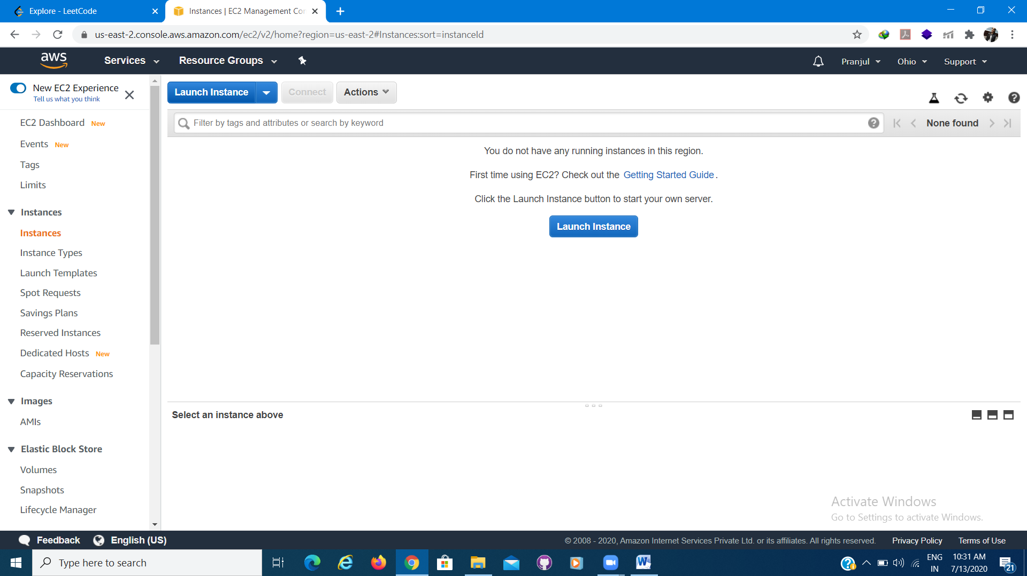

1. Choose AMI

Select Microsoft Windows Server 2019 Base (Free Tier eligible).

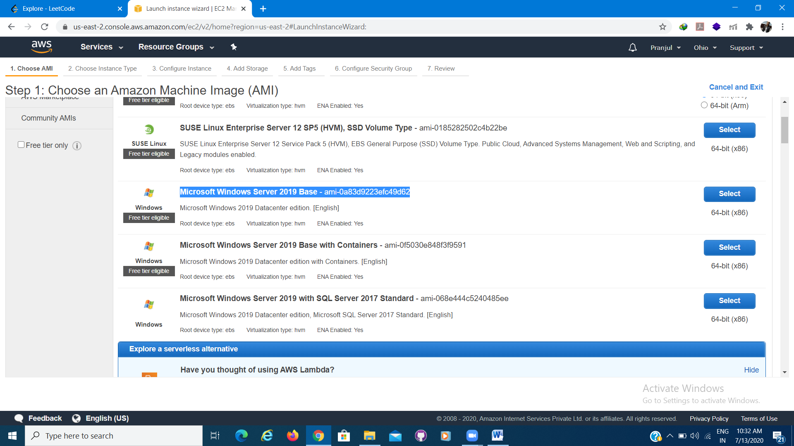

1. Choose an Instance Type i.e. t2 micro type

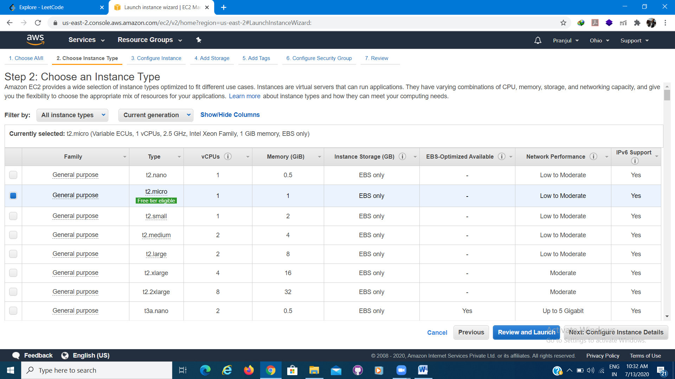

1. Configure Instance Details

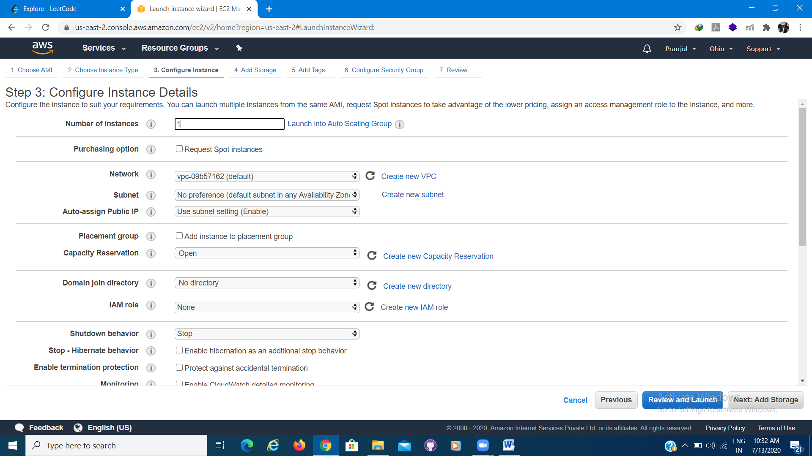

1. Add Storage

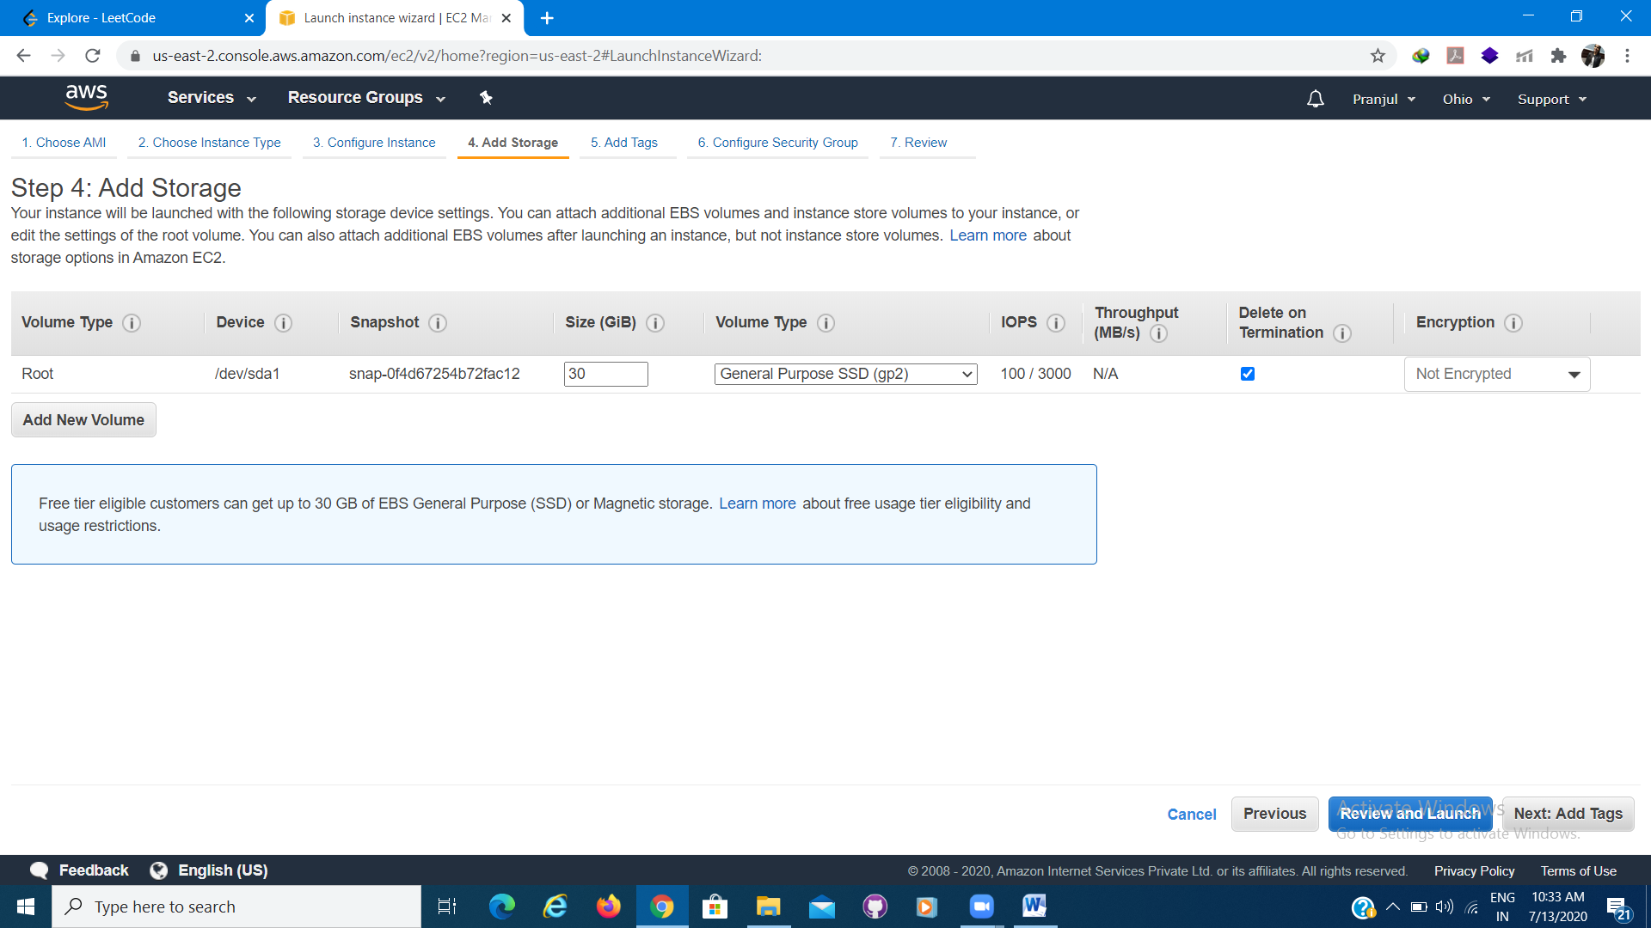

1. Add Tags

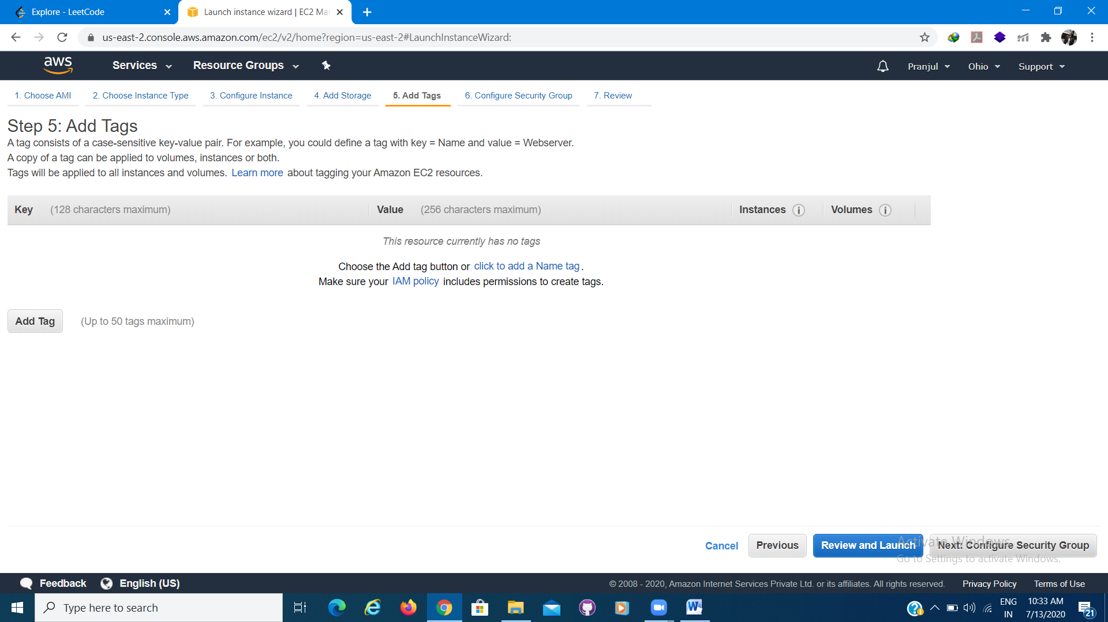

1. Configure Security Groups

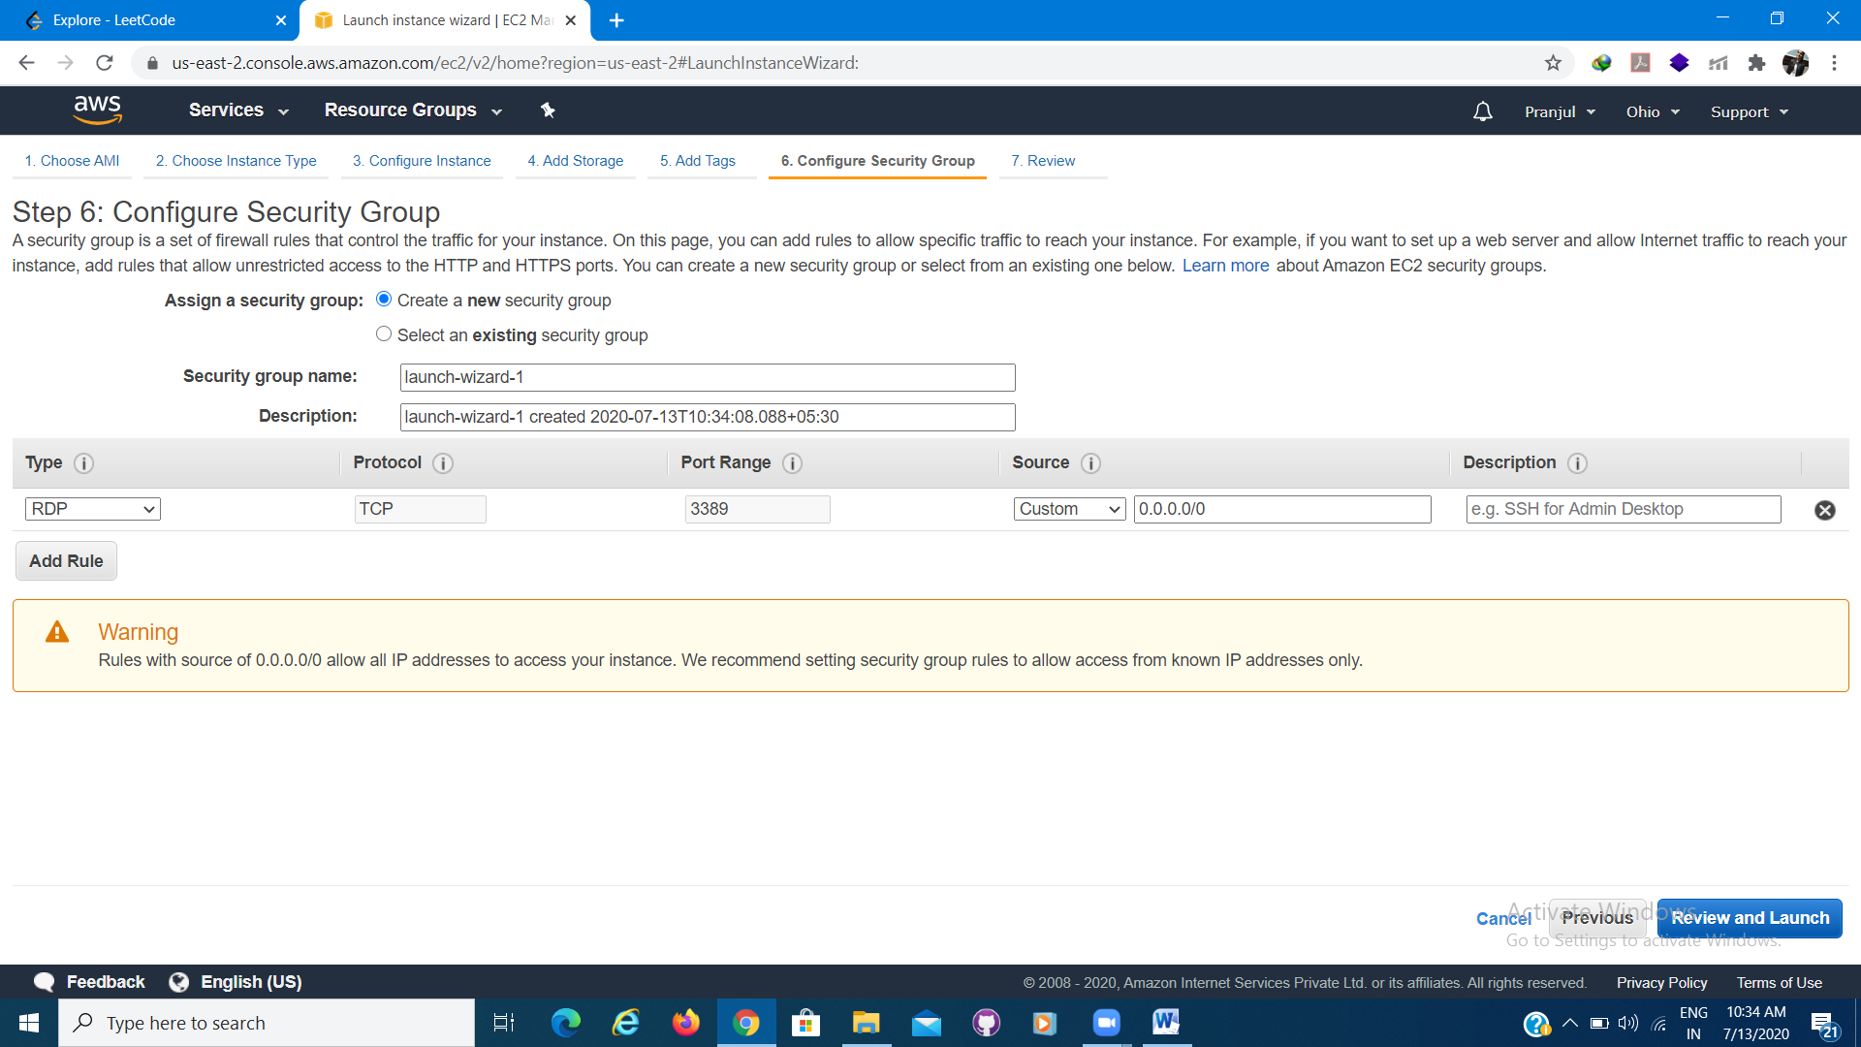

1. Review and Launch

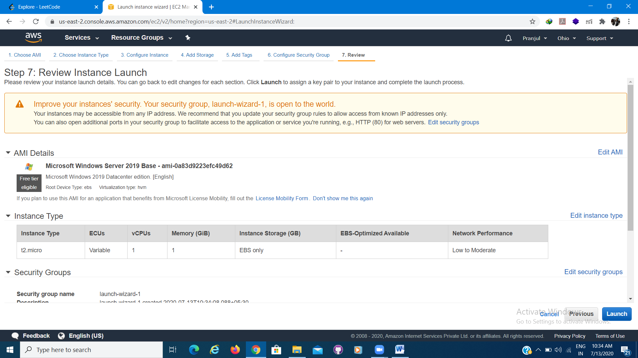

1. Create an existing or create new key pair

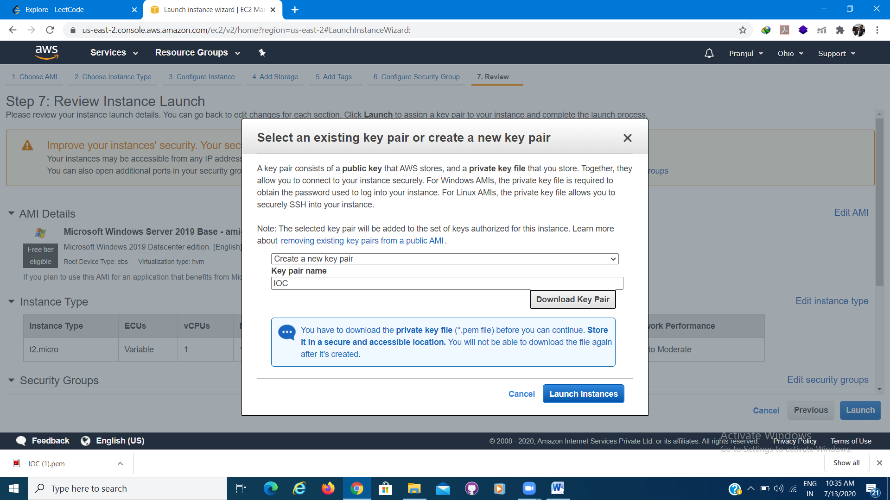

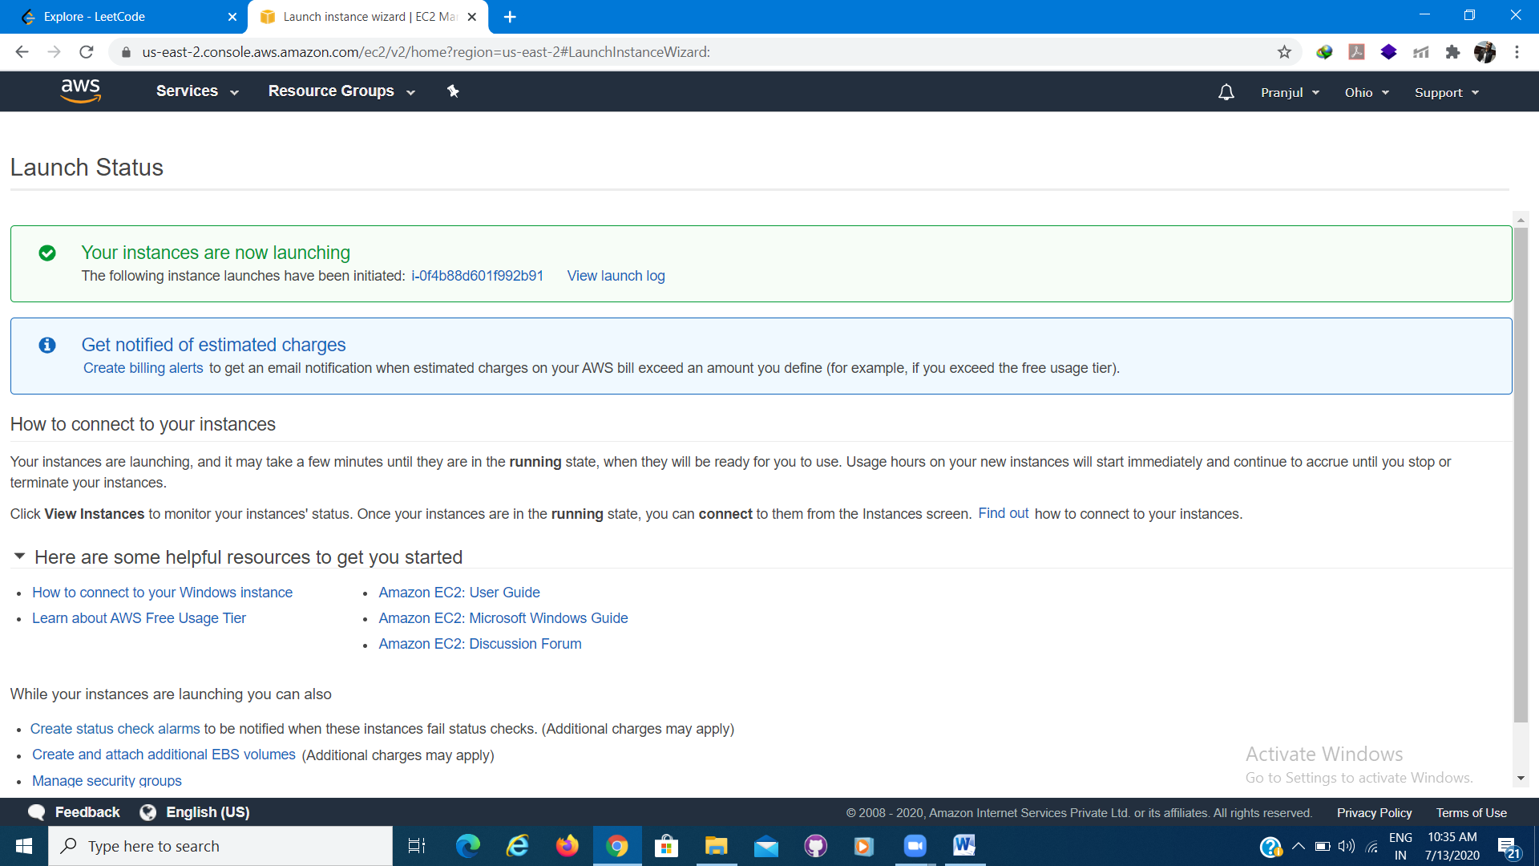

1. Click on view Instance.

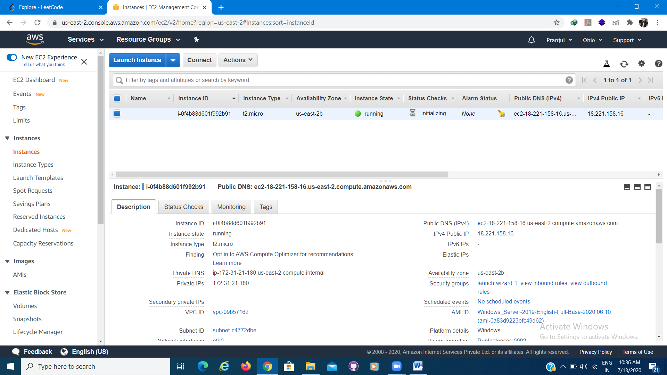

**Connect**

You can connect to a Windows Server machine using the Remote Desktop Connect.

1. In the EC2 Management Console, click Connect.
2. In the Connect to your instance popup, click Download Remote Desktop File.
3. Also click on Get Password to obtain authenticate password.
4. Load your private key and click Decrypt Password.

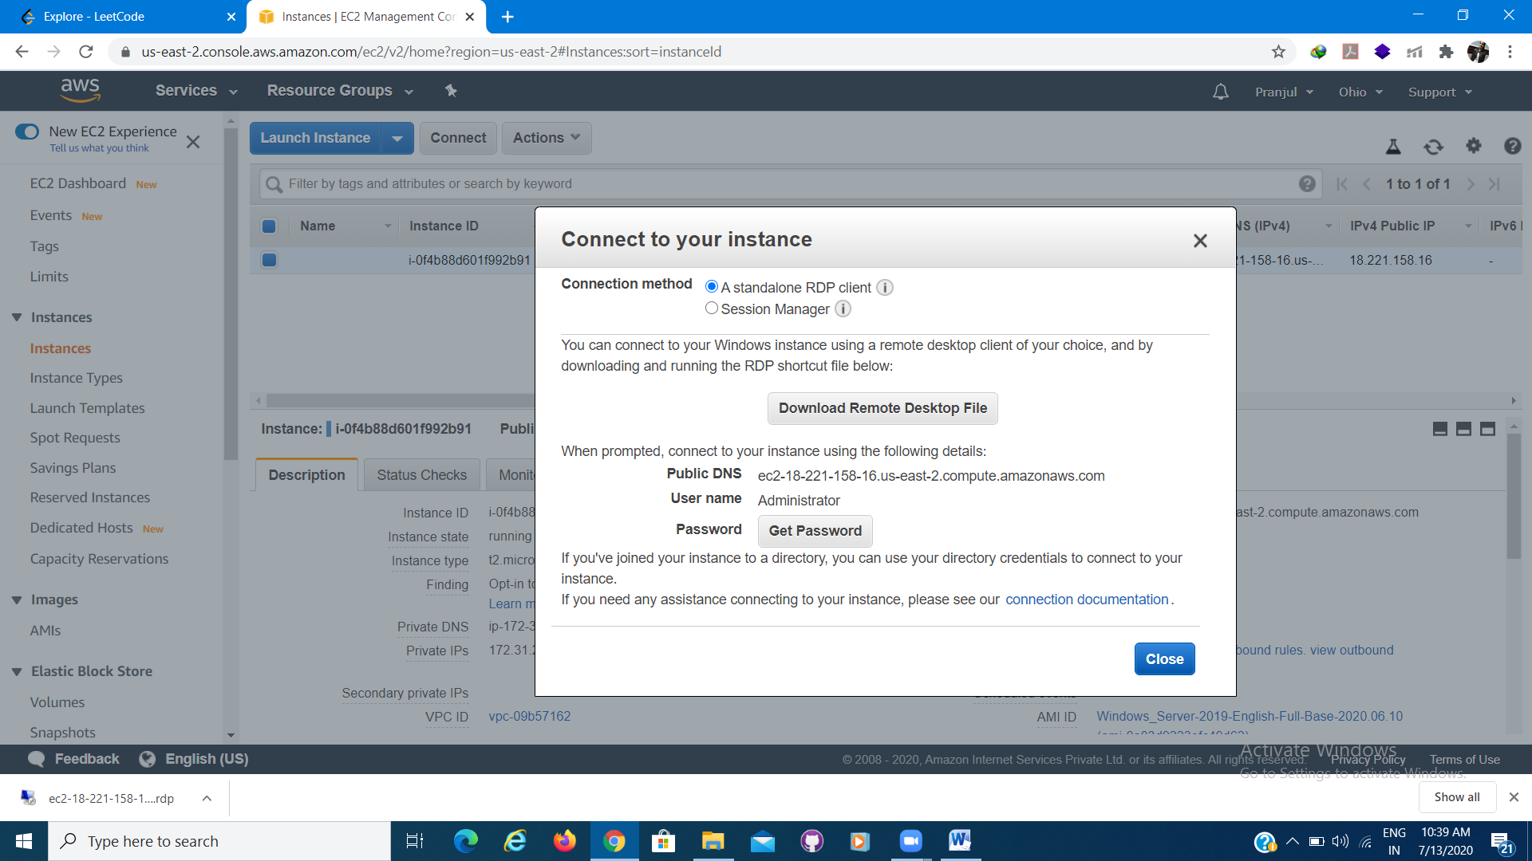

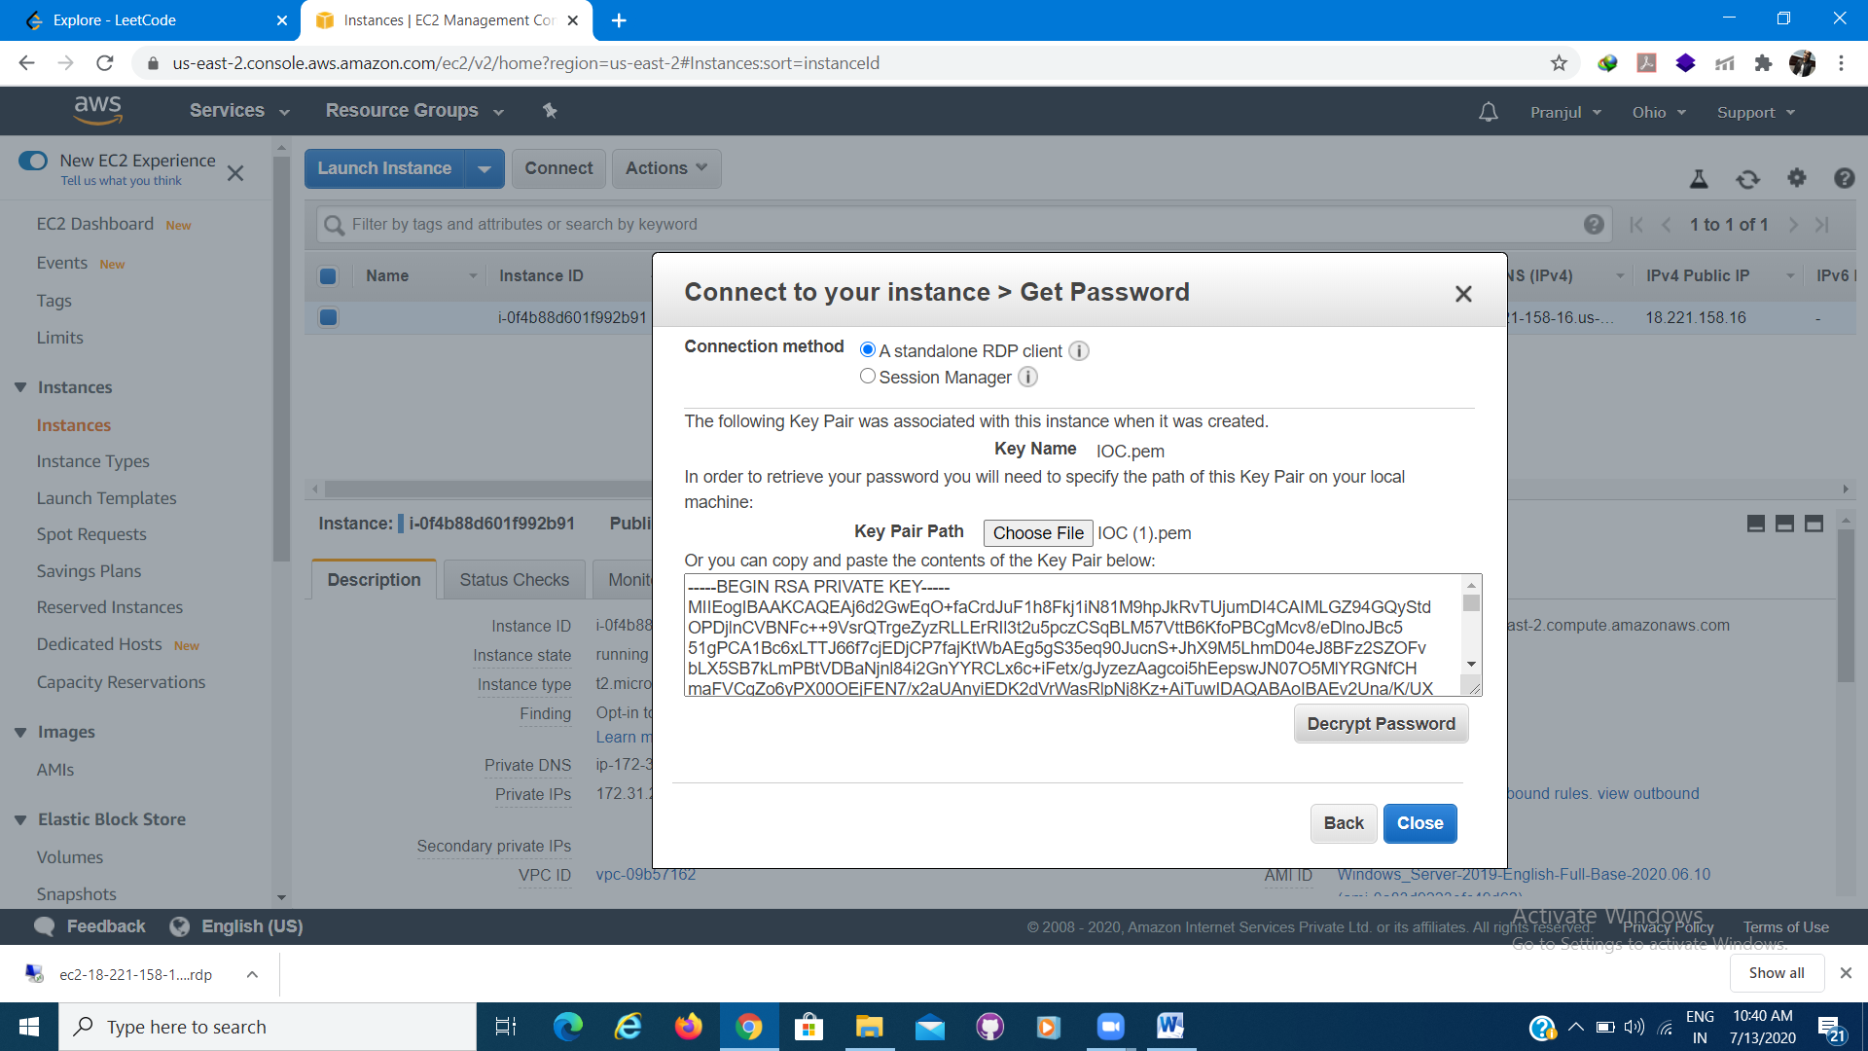

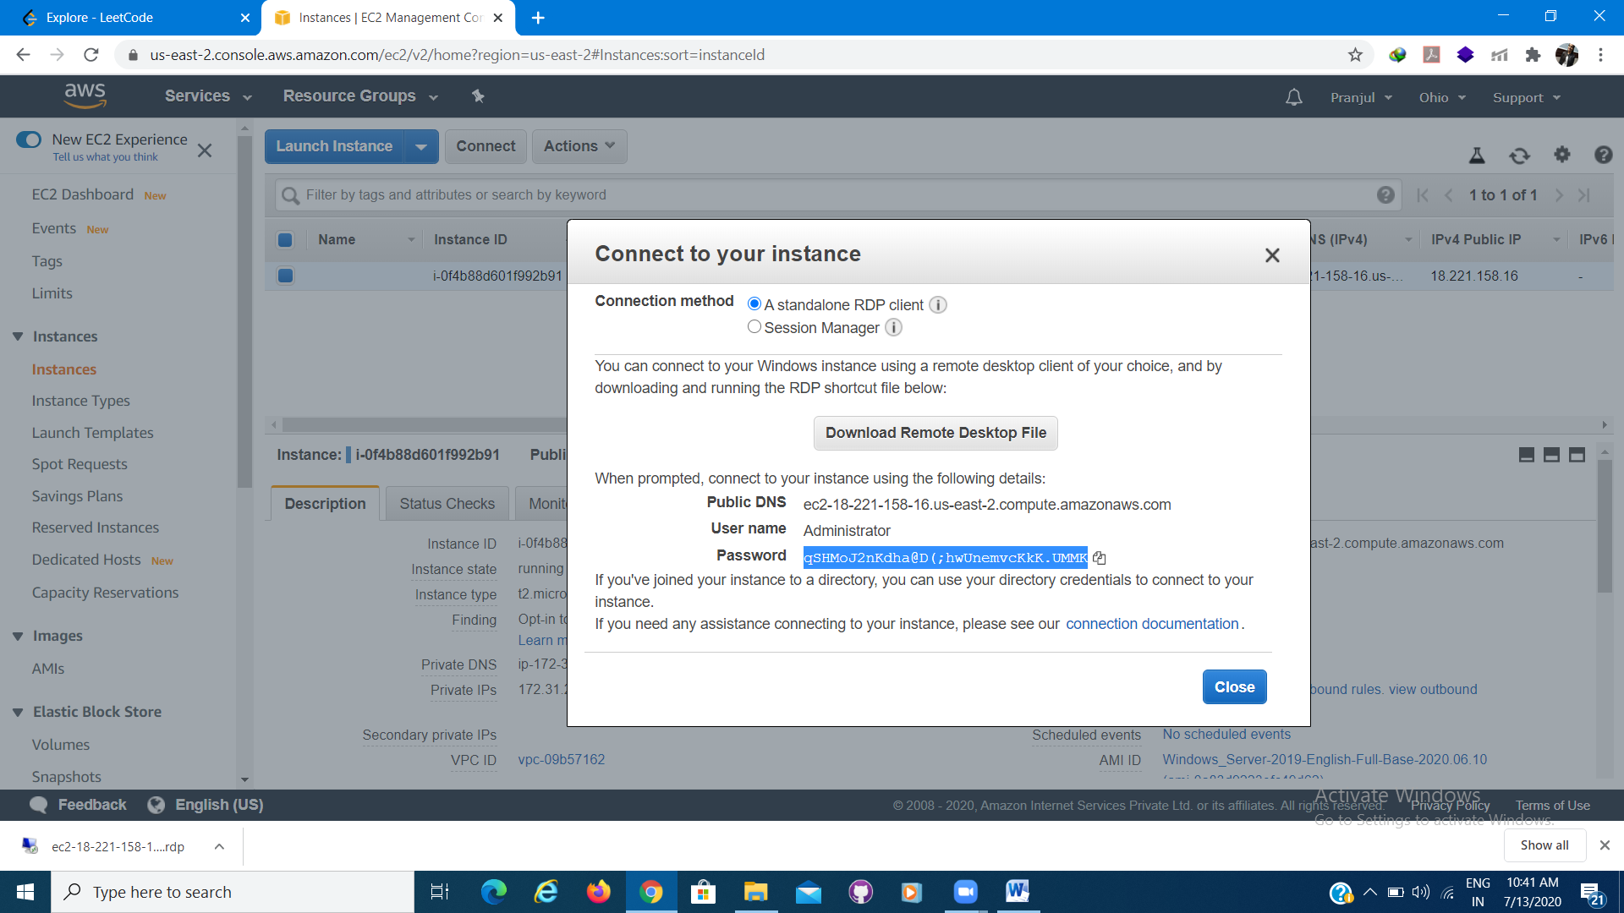

1. Open the Remote Desktop File which you have installed.
2. Click on connect.
3. Enter your credentials.

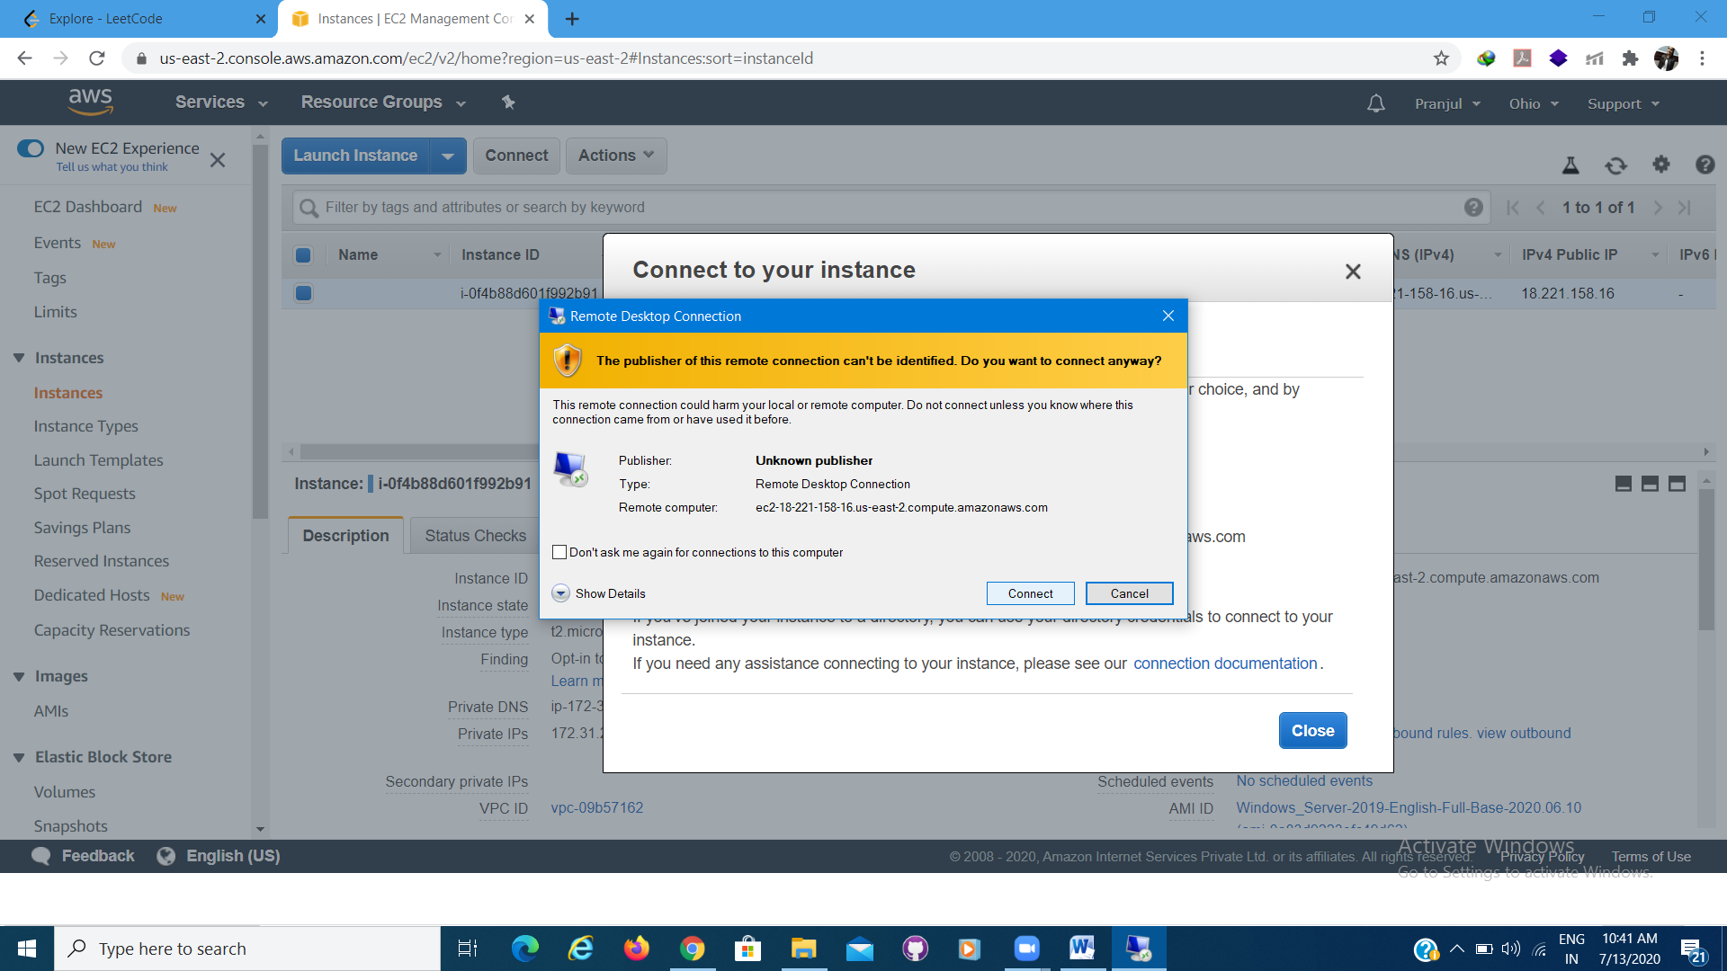

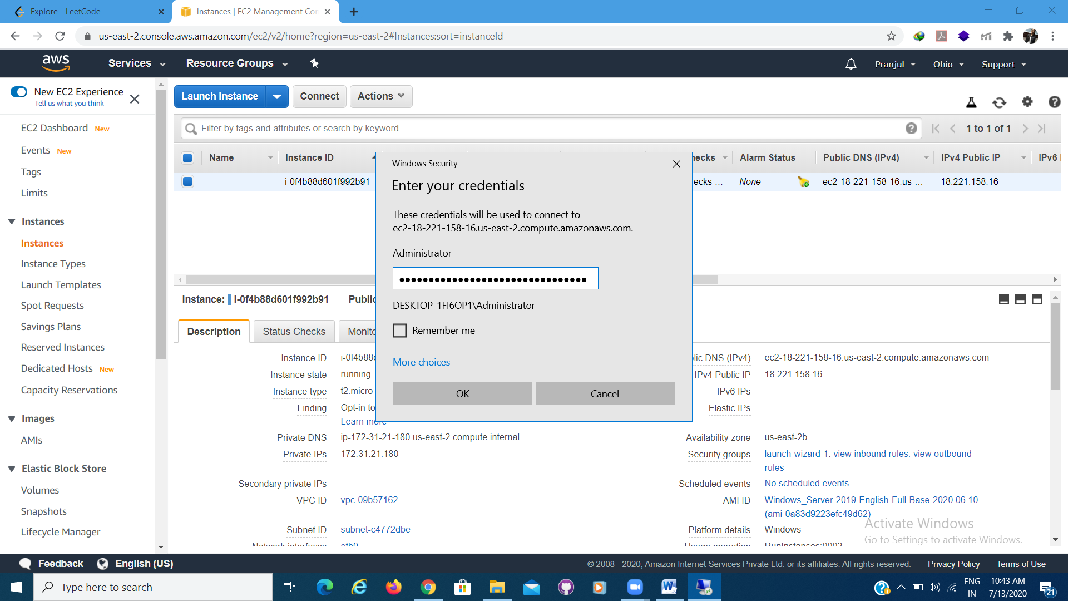

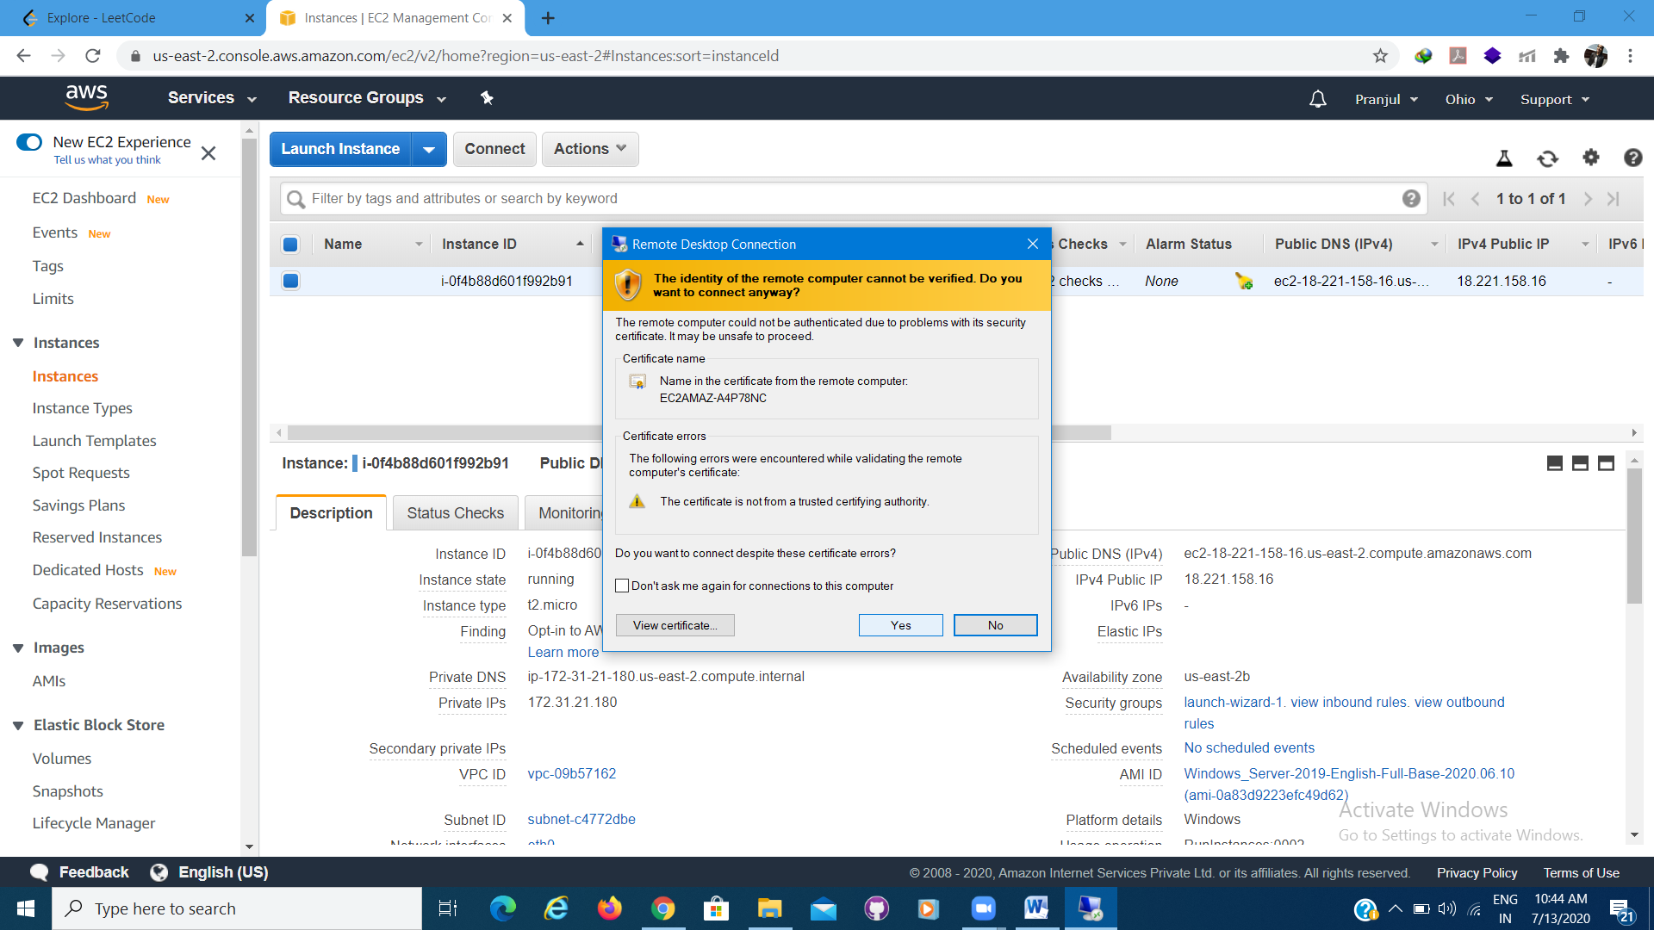

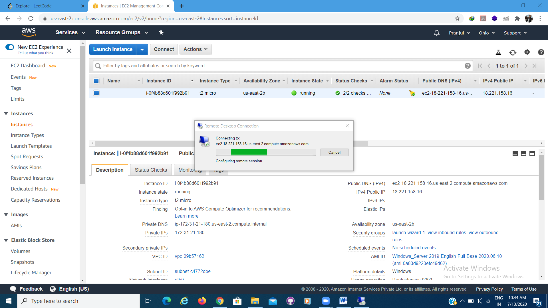

1. You are now connected to your Windows Server machine.

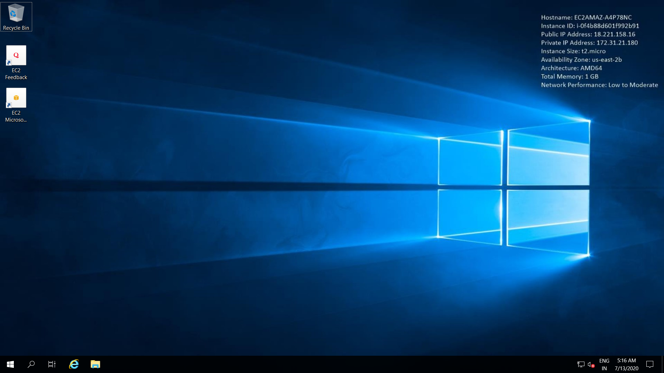

**Internet Information Services (IIS)**

1. In order to enable IIS, launch Server Manager and select Manage > Add Roles and Features

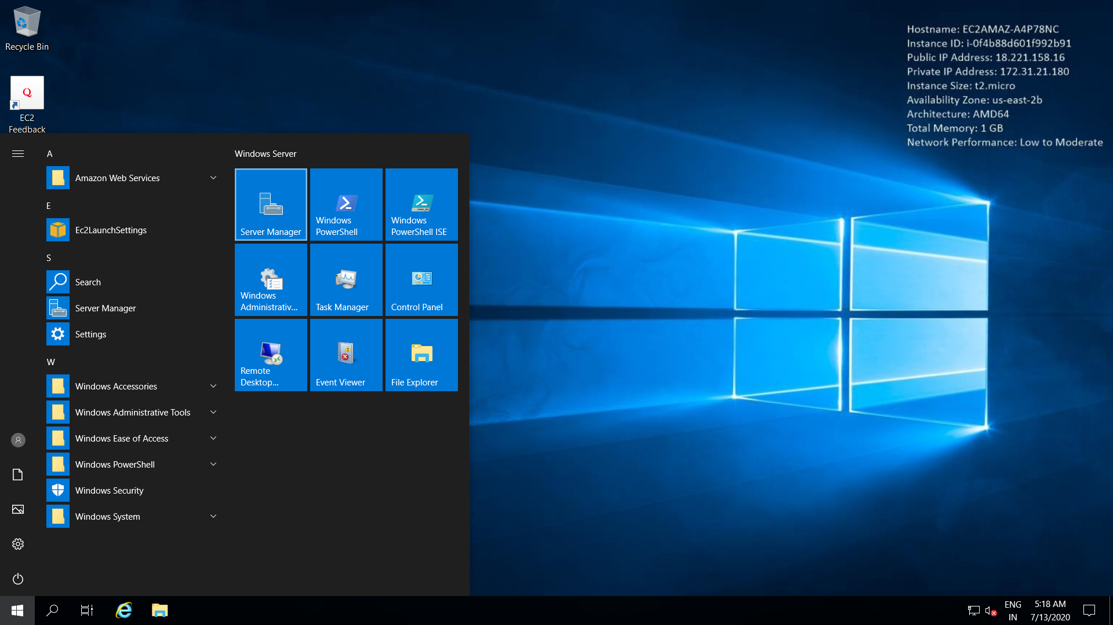

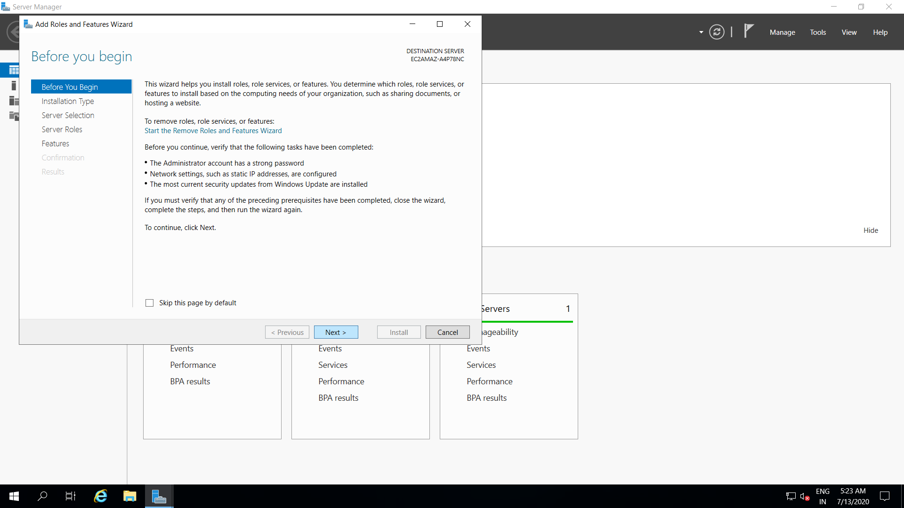

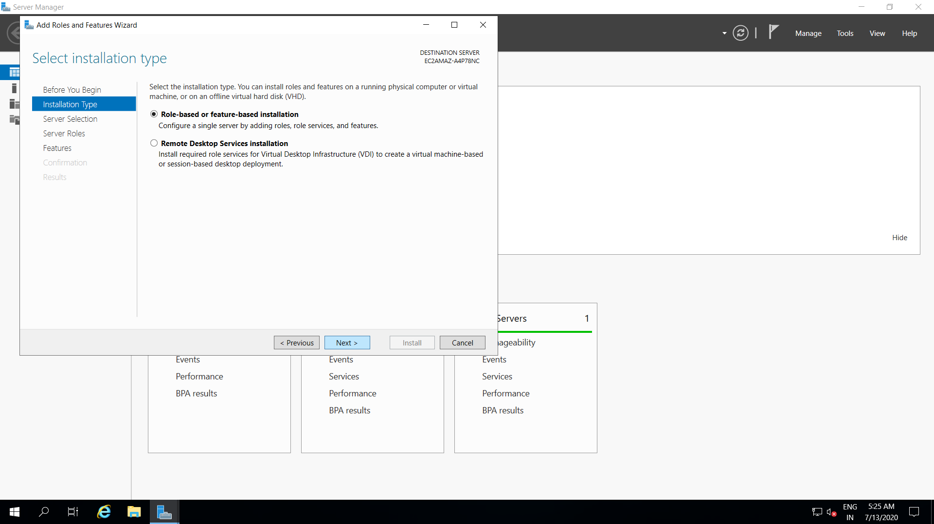

1. In Server roles choose Web Server (IIS) > Add Roles > Select Features

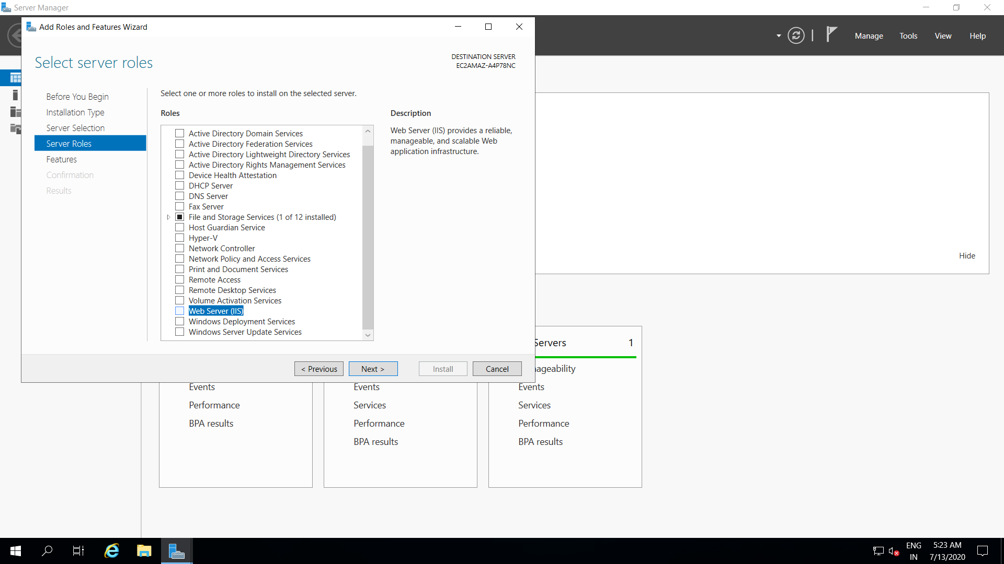

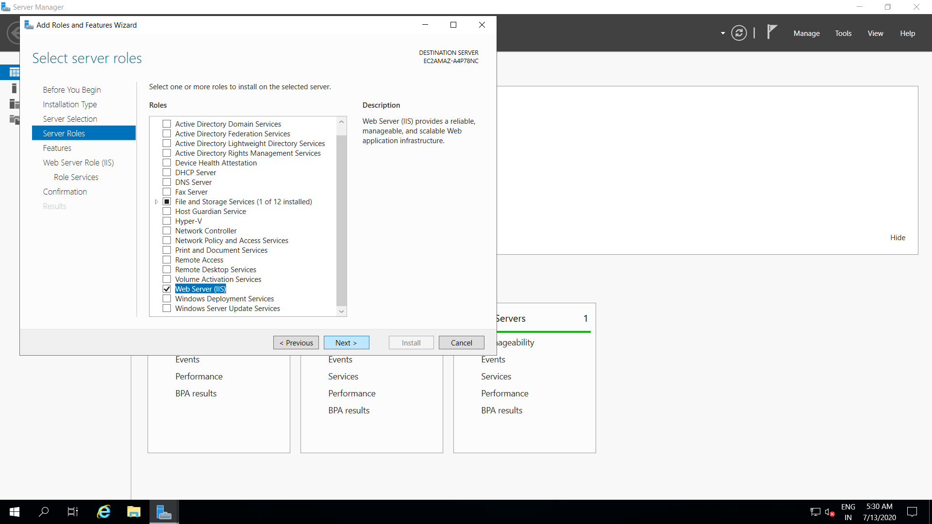

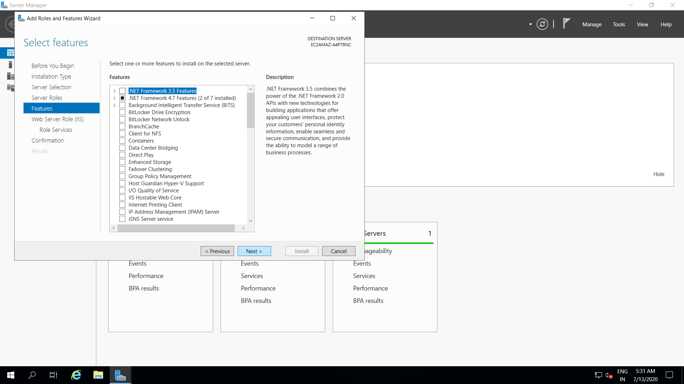

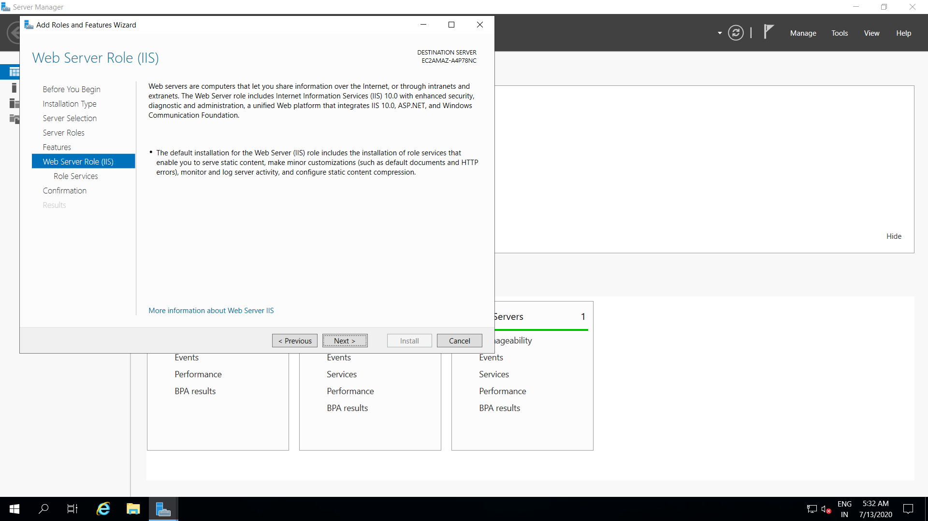

1. Click on Install, confirm installation selections

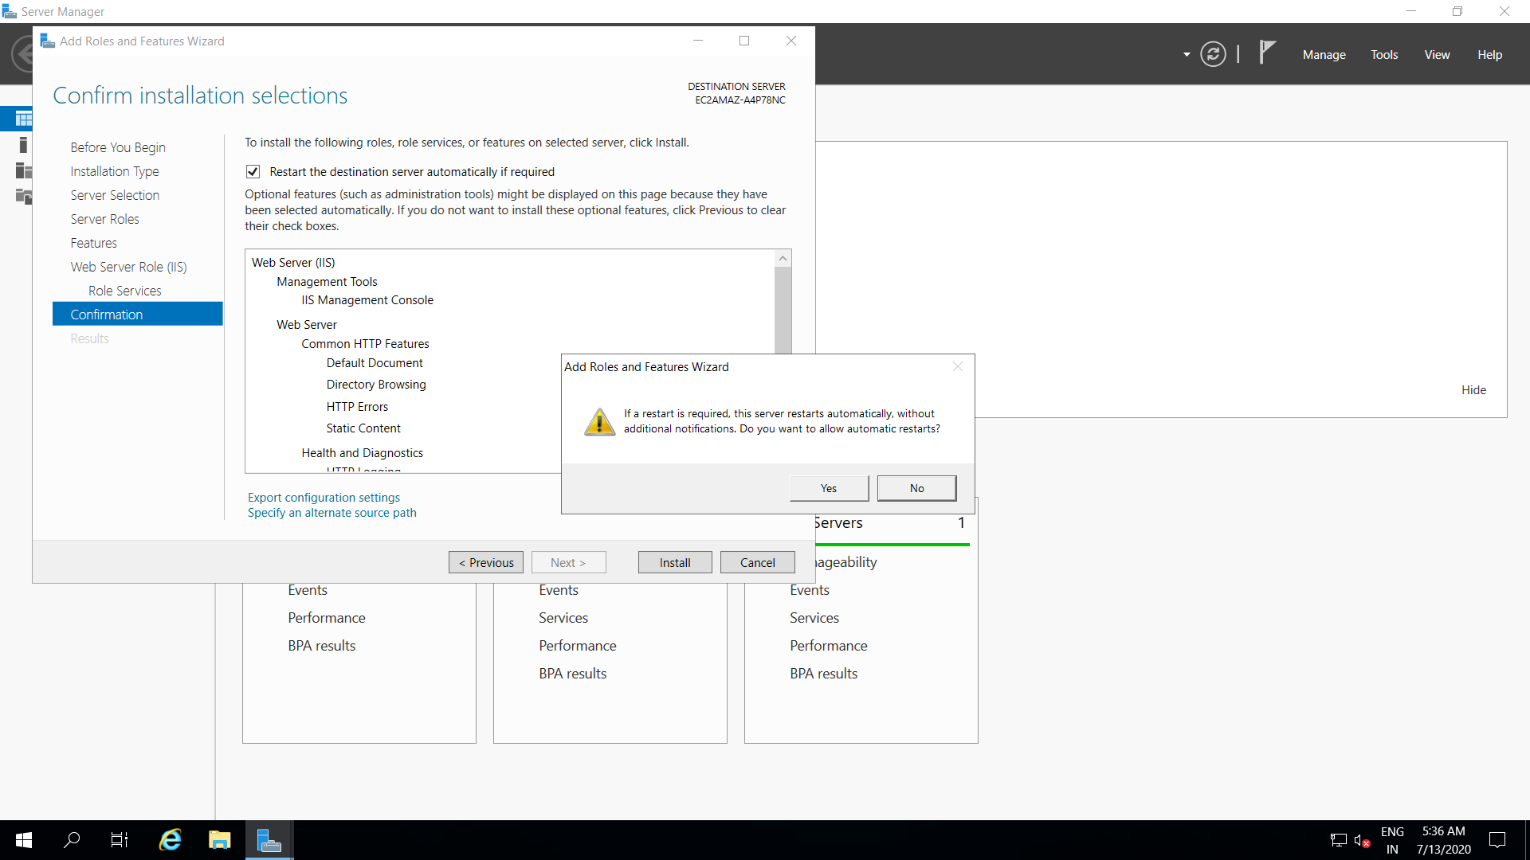

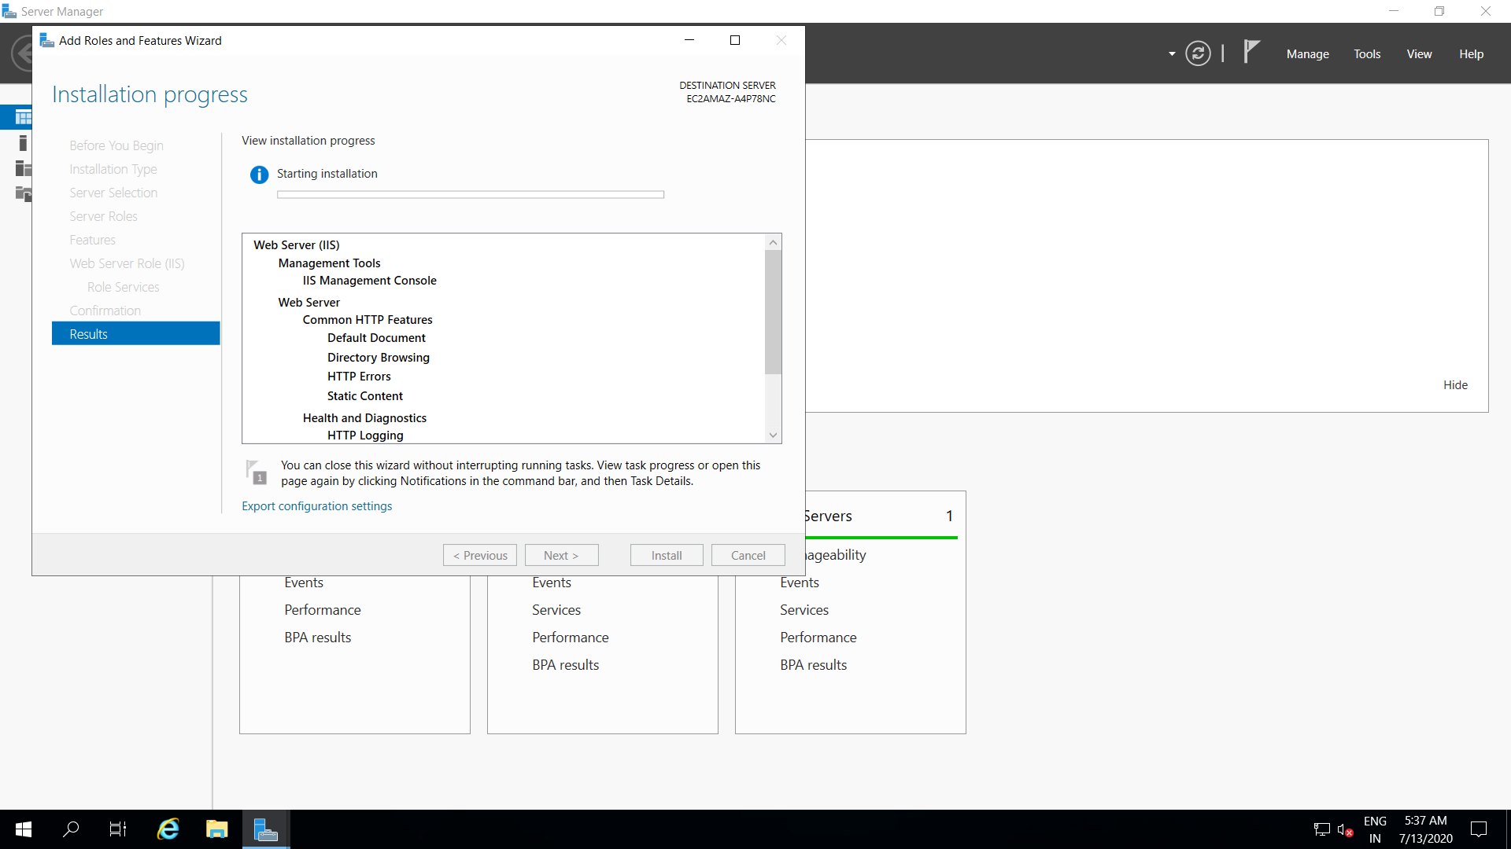

1. Now go to Local Server, click on On in Enhanced Security Configuration.

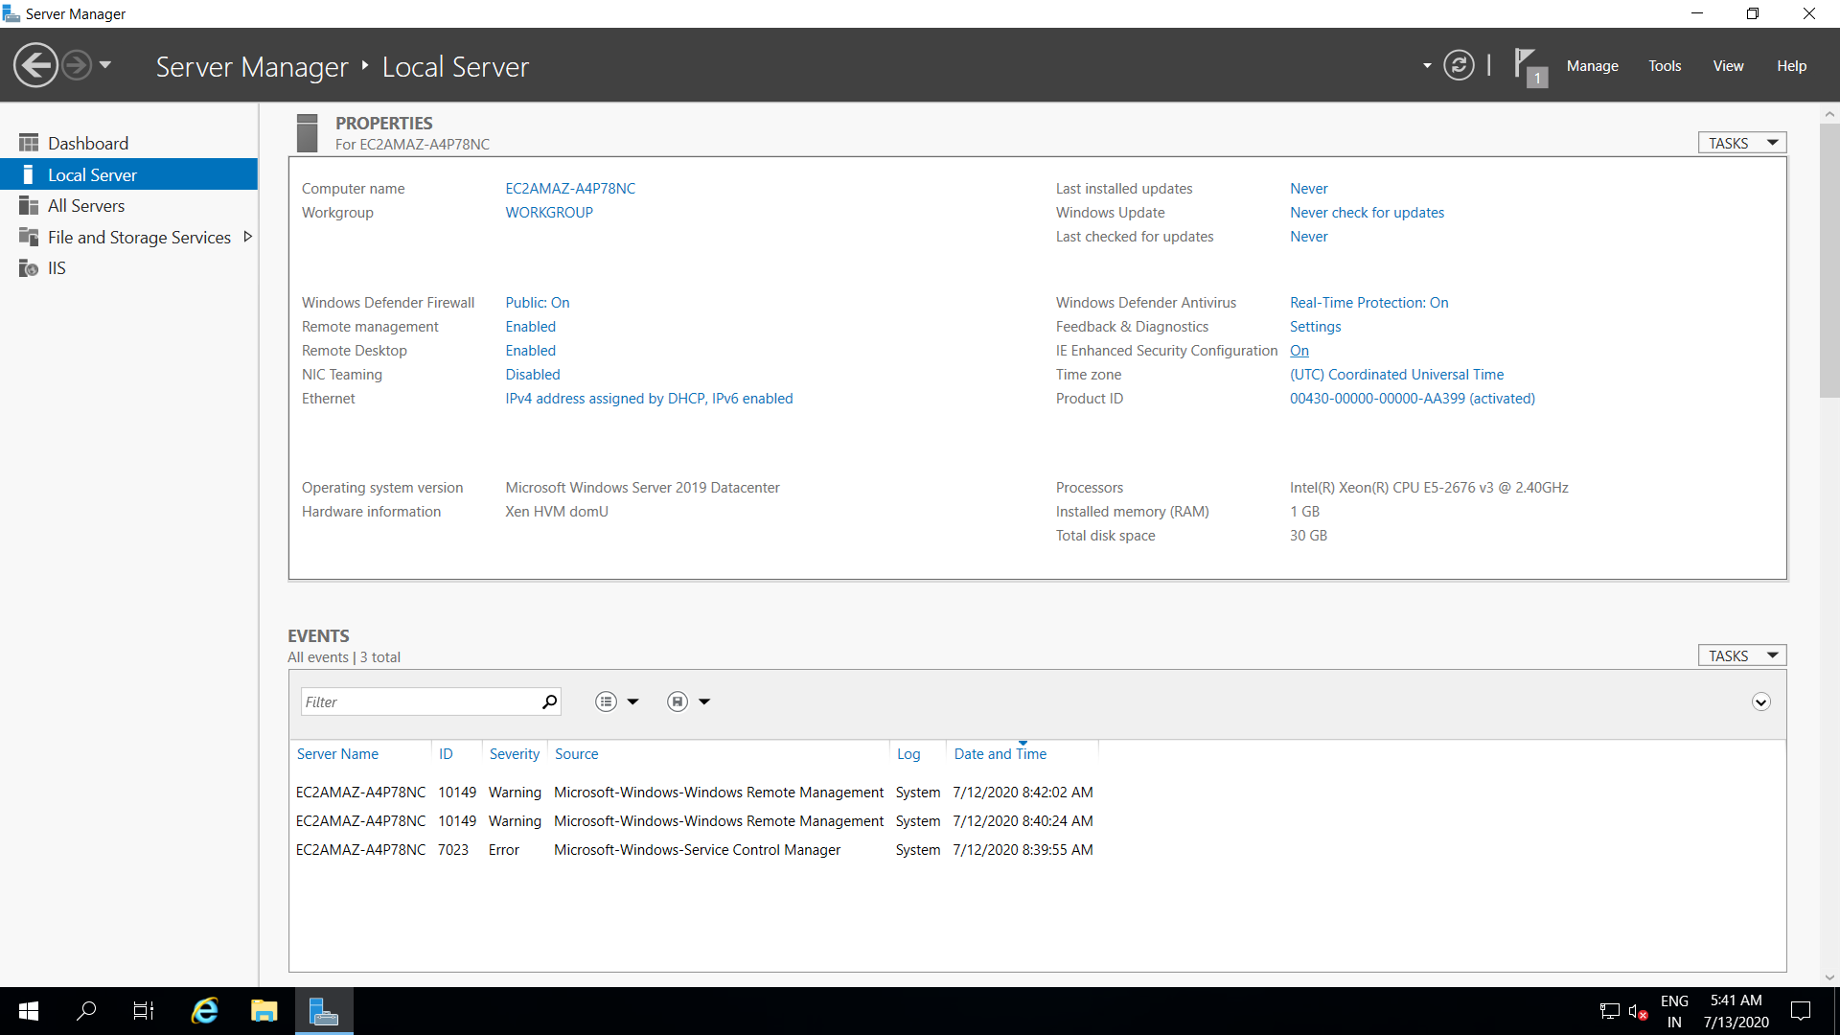

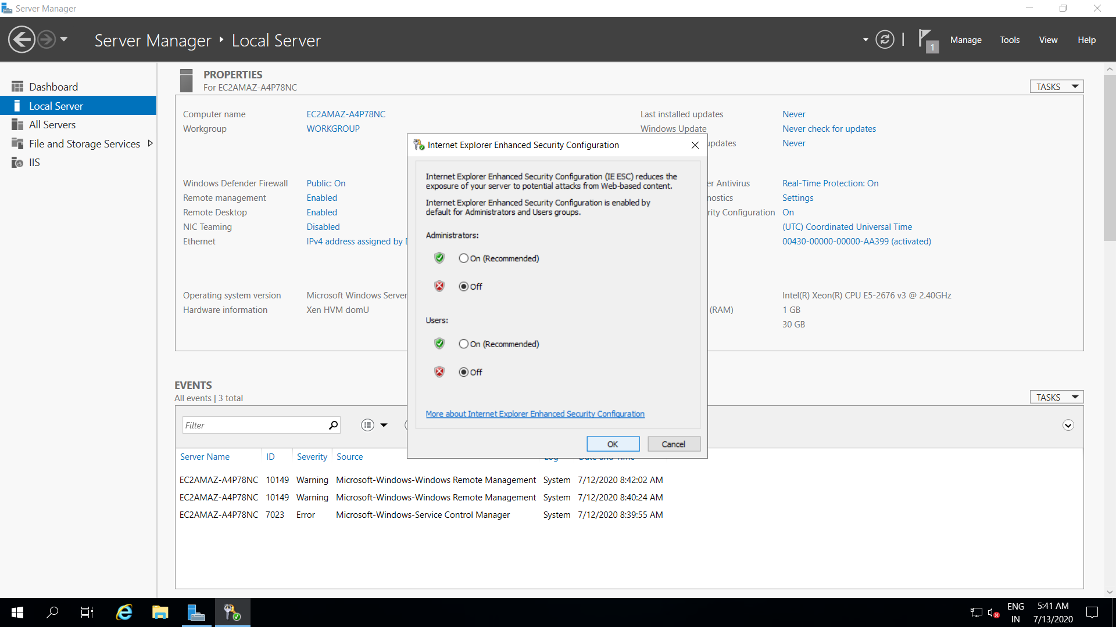

1. Open File Explorer > Local Disk(C) > inetpub > wwwroot

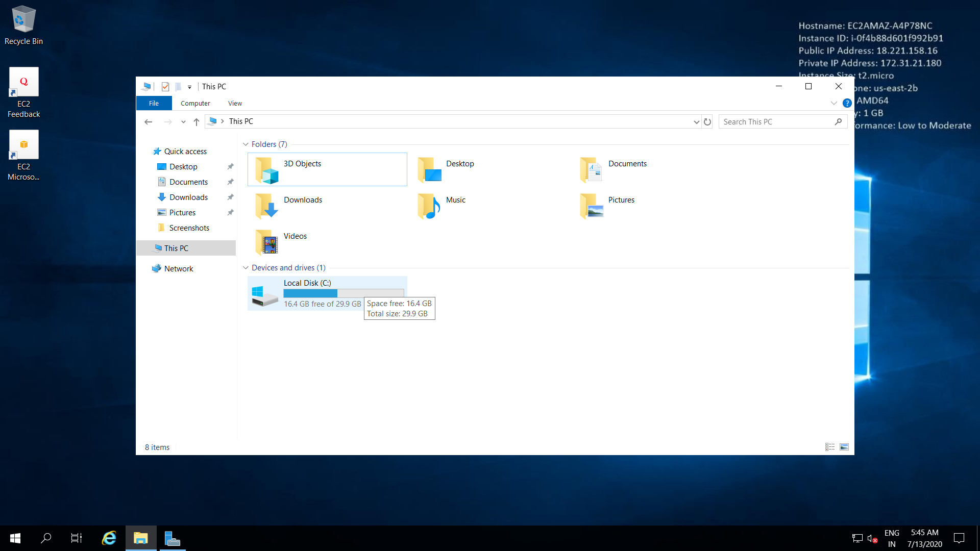

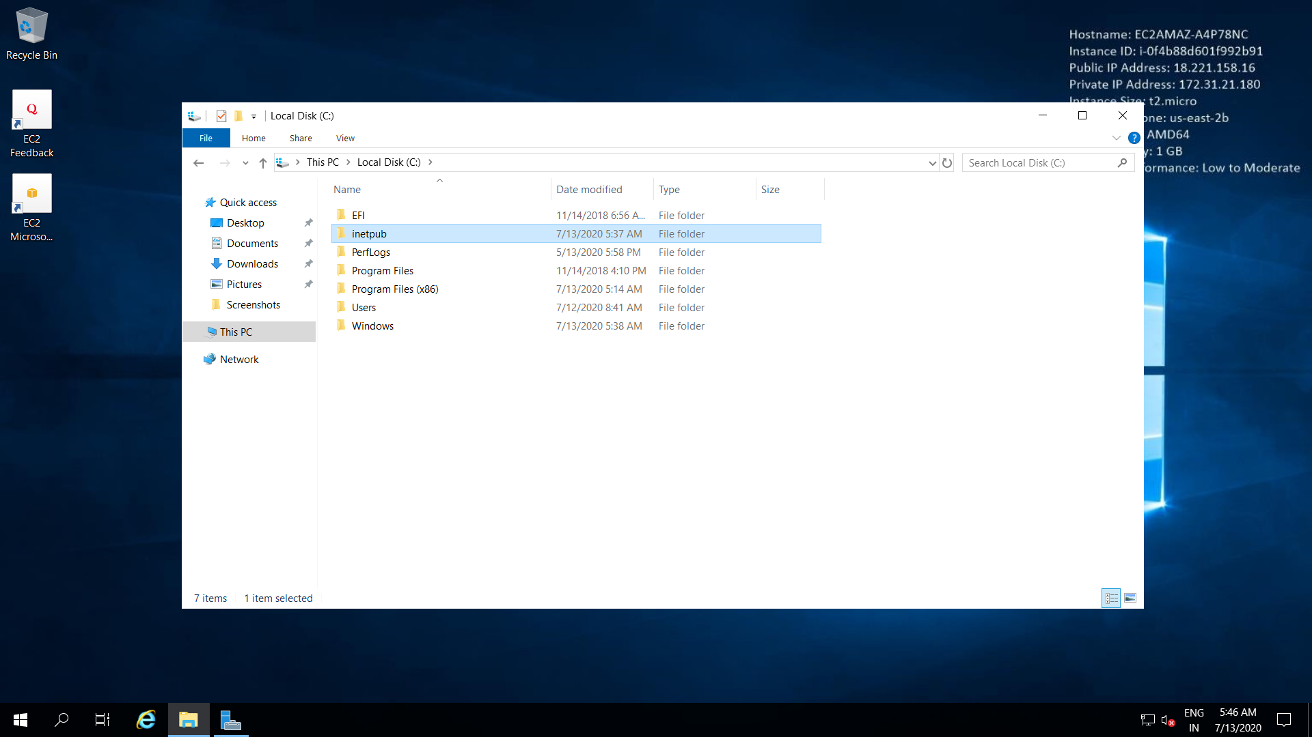

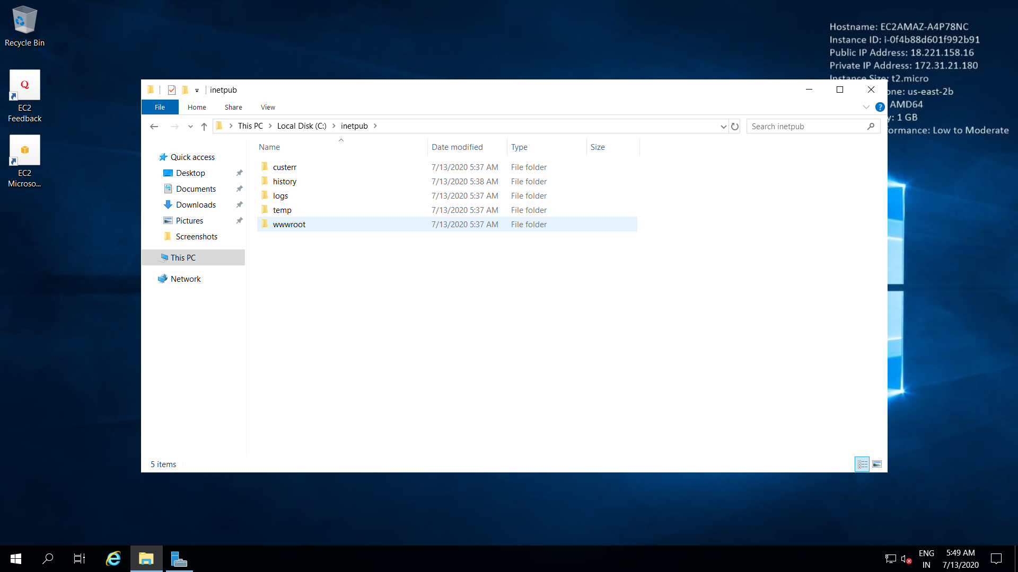

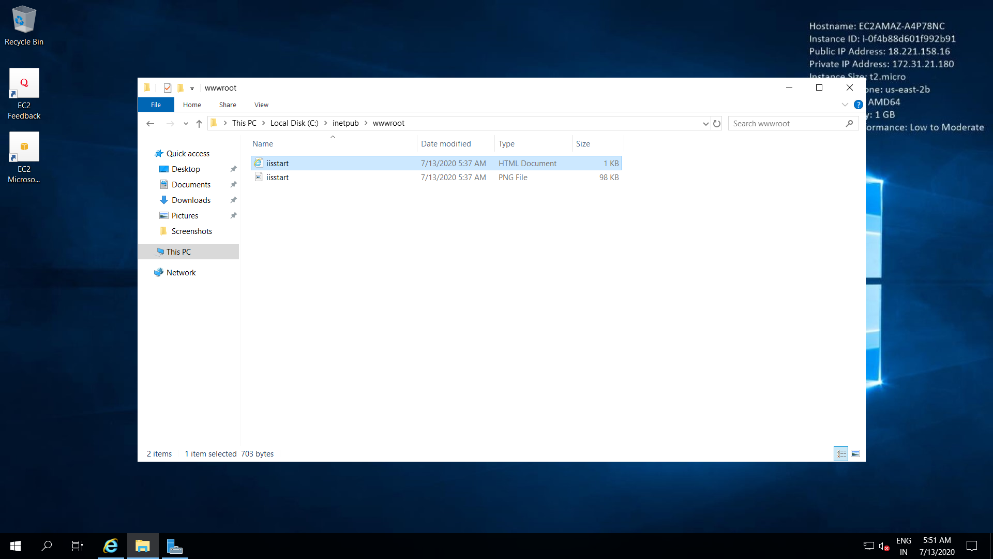

1. Again go to Dashboard > Tools > IIS Manager

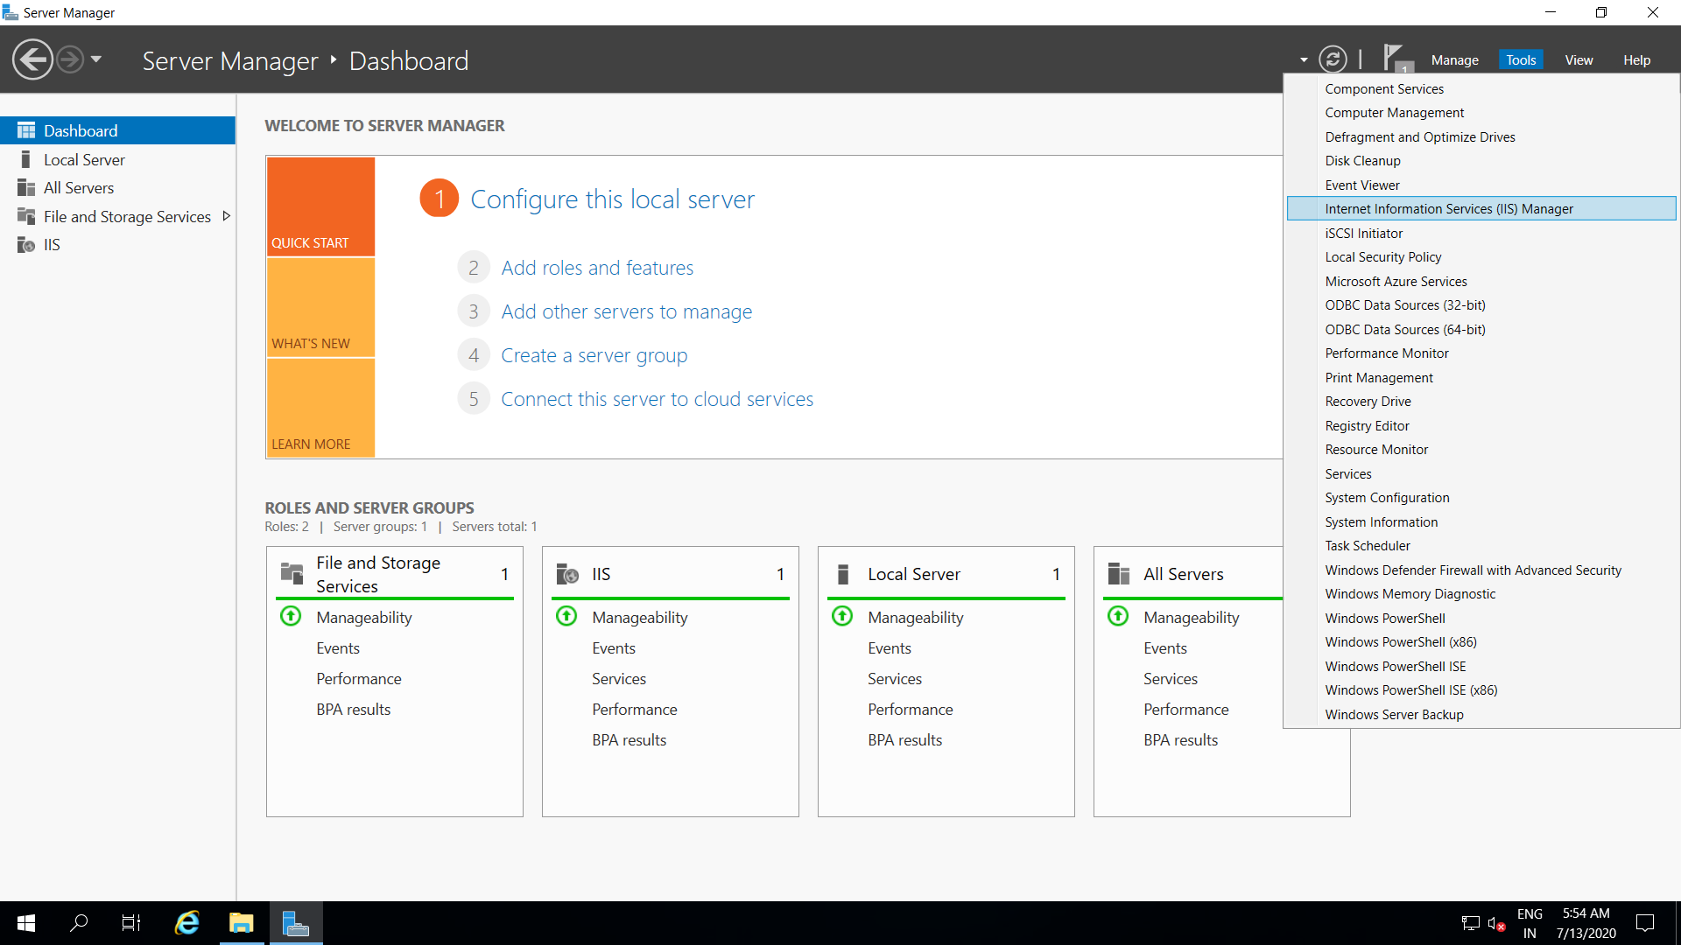

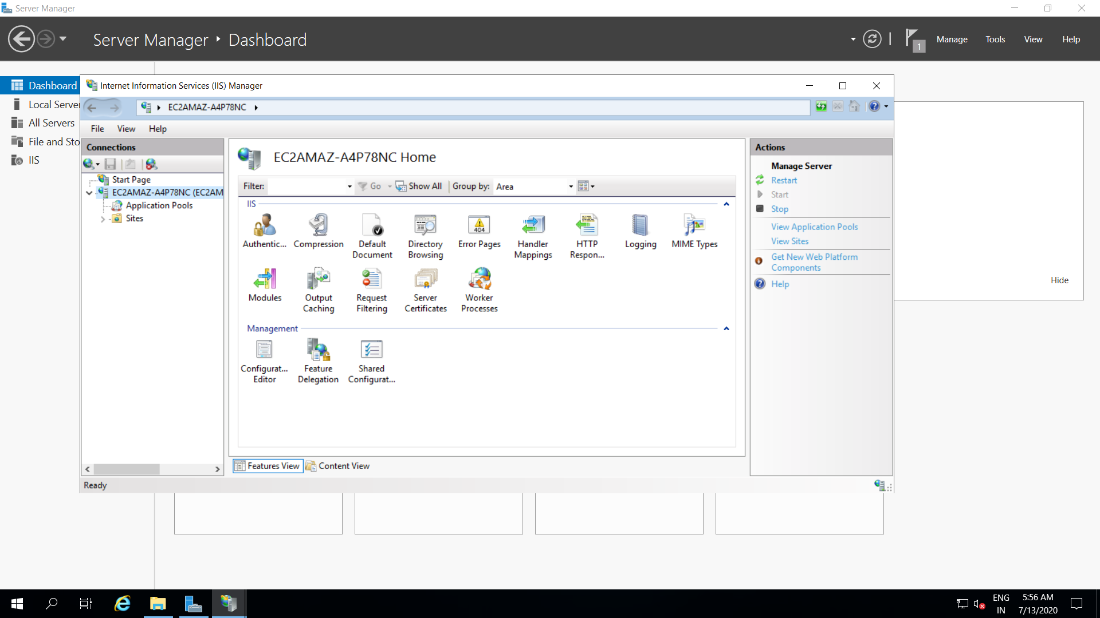

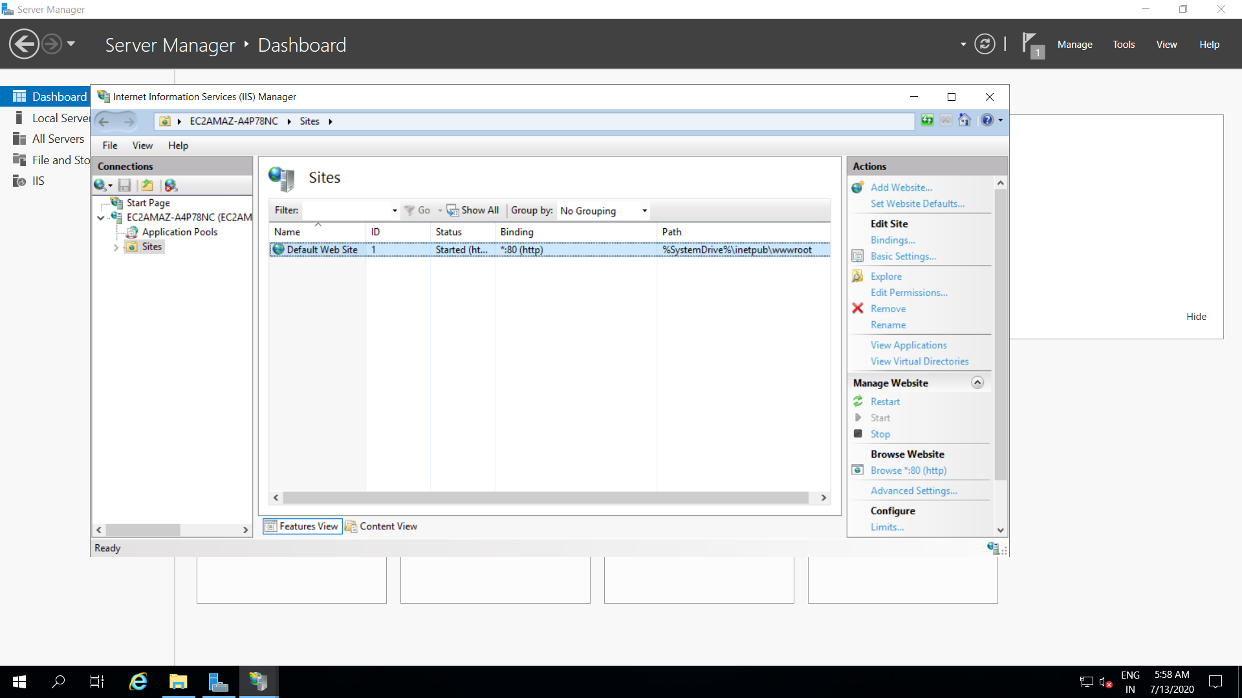

1. Click on Default Web Site 1
2. From right hand side Browse Website.

